
Specification Sheet

C.S.B. INTERNATIONAL PRODUCTS INC.

Sink Trap 1 ½" 17 GA. Ground Joint W/ C/O, B/N, D/F, R/W, 6"Cover Tube

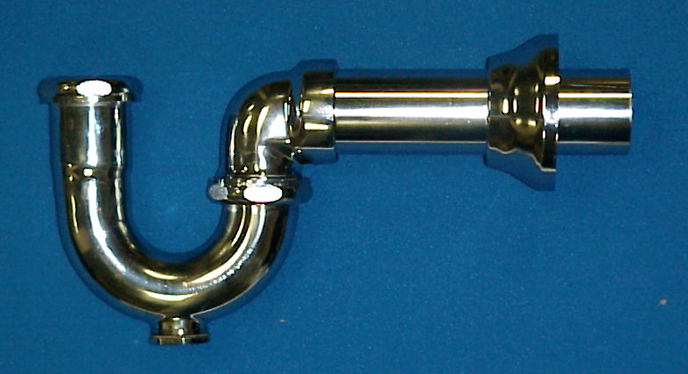
Part Number | Size | Finish | Material
1235BDCP6 | 1 ½" 17 GA. | CP | Brass

Tel: (860) 263-3635, Fax: (860) 229-4328

E-mail: sales@csbint.biz

41 Hammer Hill Road,
Rocky Hill, CT 06067

